AHAMMED YASEEN
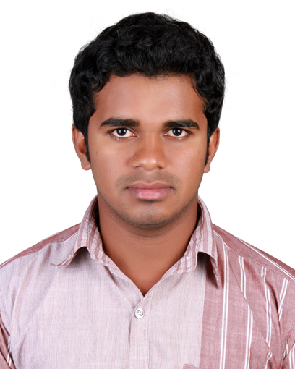  E-MAIL:yazcity@ymail.com  ADDRESS:  Po Box:6172  Al Qusais  Dubai  UAE  MOBILE:  +971565919458  PERSONAL DATA  Date of Birth : 30th Dec 1989  Gender : Male  Nationality : Indian  Marital Status : Single  Languages : English, Hindi,  Malayalam  & Tamil  PASSPORT DETAILS  Passport No : M1520694  Place of Issue : Malappuram  Date of Issue : 23/08/2014  Date of Exp : 22/08/2024  VISA DETAILS  Visit Visa Valid up to: 25/03/2016 | CAREER OBJECTIVE  Seeking career opportunity in a software organization as a software developer with a dynamic and challenging organization, which will help me to explore myself and realize my potential.  STRENGTHS  A BE(bachelor of Engineering) graduate with major specialization in computer science. Possess an enquiring mind with the ability to think clearly and logically. Possessed the ability to work accurately and pay attentions to details also I am a team player with strong communication, analytical and problem solving skills.  ORGANIZATIONAL EXPERIANCE  AIN TECHNOLOGIES - INDIA  AIN Technologies is a premier IT solutions and service provider, established in 2000, Providing cutting-edge ERP Software, GIS Application Development, Mobile App Development, Website Design and Development. AIN having offices in the Middle East and India.  Period: Aug 2013 – Sep 2015  Designation: Software Developer  Responsibilities  - Responsible for designing, coding and debugging  applications in various software languages  - Responsible for software analysis, code analysis,  requirement analysis and system risk analysis  - Software modeling and simulation  - Responsible for support, maintain and document  software functionality  - Integrate software with existing systems  - Identify new technologies for implementation  - Maintain compliance standards  - Implement localization or globalization of software as per the requirement  - Prepare software designs as per the requirements of the clients  - Modification of existing software to improve its  Performance.  - Database design and implementation including tables, stored procedures, indexes, functions and views.  - Design and implementing workflows in line with the business requirements.  - Software testing and quality assurance

DIMIND INNOVATOINS - INDIA

Dimind innovations is one of the leading and most diversified information technologies in Web Design and Software Development organization based in Kochi, Kerala, India.
Period: Feb: 2013 – Jul: 2013

Designation: Junior Software Engineer
Key Areas
- Involved in design and implementation of UI(user interface) Modules.
- Modifying the existing design and developing new modules, to provide the functionality required by the client.
- Database design and implementation including tables, stored procedures, indexes, functions and views.
- Prepare software designs as per the requirements of the clients
- Implemented enhancements to the application as a part of the maintenance and upgrade process.

PROJECTS
PROJECT: ACOMS
Type: Web Based Application (ASP.NET 4.5/C#, SQL Server 2008)
Description: ACOMS is the pilot project I have done for a leading company in india, this web application used for all kind of activities (Reception, administration, operations, accounts and HR) of the company.
PROJECT: S2MS
Type: Windows application (Windows form C# 4.5, SQL Server 2012)
Description: S2MS is super market management system, it is functioning to make sales order, purchase order and inventory management.
PROJECT: DAZZLE SHOPEE
Type: Web Based Application (ASP.NET /C#, SQL Server 2008)
Description: It is an Online shopping web application created for online shopping organization, it will help their customers can make booking, order, purchase and payment through this web.
ACADEMICS

BE (Computer Science & Engineering) Anna University 2012

HSE Govt.higher secondary Puthuparamba 2008

SSLC KHM High School 2005

TECHNICAL EXPOSURE

- Programming Language: C#&.NET, ASP.NET, C, C++, SQL, HTML, JEE
- CSS, Jquery, JavaScript, Ajax, XML.
- Database: SQL, ORACLE
- Operating System(Working Knowledge):Windows, Linux
- IDE: Visual Studio, Eclipse
- Package known: MS Office, Photoshop

ACADEMIC PROJECTS

AS A PART OF BACHELOR OF ENGINEERING PROGRAM:

Title : “Virtual Clusters for Grid Communities”

Duration : Jan 2012 - April 2012

Organization : Blue Chip

Objective : In this project, we explore this scenario to deploy a computing cluster
On the top of a multi cloud infrastructure, for solving loosely coupled many
task computing (MTC) applications. In this way, the cluster Nodes can be
provisioned with resources from different clouds to improve the cost
effectiveness of the deployment or to implement high-availability strategies.

Methodology : Java

INTERNSHIP AND TRAININGS:

Attended training on “Ethical Hacking” in CMS ltd Cochin on 9th March 2013

SEMINAR AND PAPER PRESENTATION
- Attended Red Hat Seminar “The Open Cloud-Way Ahead 2014” in Red Hat India
Pvt. Ltd & IPSR Solutions Ltd.
- Paper presentation at Oxford College Trichy on the topic “Mobile Computing”

EXTRA-CURRICULAR ACTIVITIES

Active social worker as a part of “SCOUTS AND GUIDES” (RAJYAPURASKAR)

HOBBIES

- Reading books
- Watching news channels and movies
- Listening to music
- Wild life Photography
- Driving and Travelling

DATE

PLACE AHAMMED YASEEN

